Title: Synthesis of acetyl salicylic acid

Theory:
Acetylsalicylic acid is synthesized from salicylic acid and ethanoic anhydride.
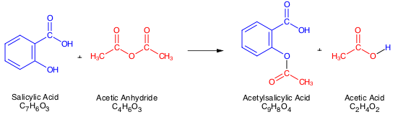

Material:
Test tubes Buchner funnel and suction flask
water bath (pot & hotplate) filter paper
ringstand & clamp paper forms
pot for ice bath glass rod
Pasteur pipette Boiling chip

Chemicals:
salicylic acid
catalyst: conc. Phosphoric acid, conc. Sulfuric acid, 1 M NaOH
acetic anhydride
ice
cold dH₂O

Procedure:

- Add 138mg salicylic acid, a boiling chip, a small drop of catalyst, and lastly 0,3ml acetic anhydride to a test tube. Make sure that all the reagents are washed to the bottom of the test tube with the acetic anhydride.
- Mix the reagents thoroughly and heat in a 90°C waterbath for 5 min.
- Remove the testtube and add 0,2ml water carefully. This will remove the excess acetic anhydride. This is an exothermic process!
- When the reaction has ceased, add 0,3ml water and allow the reaction mixture to come to room temperature.
- Cool the testtube in an icebath for at least 10 min. If you don’t get crystal formation, scrape the sides of the flask with a glass rod.
- Remove the solvent with Pasteur pipette or by suction filtration.
- Use small volumes of cold water to transfer all of the product to the funnel.
- Let the product dry on a filter paper.

